PROJECT REPORT ON
“SCADA Based Thermal Power Plant”
A Project Report Submitted in Partial Fulfillment
of the Requirements for the Degree of
Bachelor of Technology
In
DEPARTMENT OF ELECTRICAL ENGINEERING
By
Vivek Rawat (2400650200028)
Vaibhav Singh (2400650200027)
Under The Guidance of:
Mr. Ram Chandra Gupta (C.O.E, BSACET)
&
Mr. Dushyant Bansal (HOD, EE Department)

BSA COLLEGE OF ENGINEERING & TECHNOLOGY
Established & Governed Shri Agrawal Shiksha Mandal (Regd.), Mathura

to the
DR. A.P.J. ABDUL KALAM TECHNICAL UNIVERSITY
(Formerly Uttar Pradesh Technical University,Lucknow)

DECLARATION

We VIVEK RAWAT (2400650200028) and VAIBHAV SINGH (2400650200027) hereby declare that the project Reported entitled “SCADA BASED THERMAL POWER PLANT” done by us under the guidance of Mr. Ram Chandra Gupta & Mr. Dushyant Bansal is submitted in partial fulfillment of the requirements for the award of Bachelor of Technology in Electrical Engineering.

1. Vivek Rawat (2400650200028)

2. Vaibhav Singh (2400650200027)

SIGNATURE OF THE CANDIDATES
DATE: 07/10/2026

ACKNOWLEDGEMENT

Acknowledgement We would like to express our sincere gratitude to everyone who has helped and supported us in completing our project titled “SCADA Based Thermal Power Plant.”
First and foremost, we extend our heartfelt thanks to our project guide, Mr. Ram Chandra Gupta & Mr. Dushyant Bansal for their valuable guidance, constant encouragement, and continuous support throughout this project. Their advice and insights have been instrumental in helping us understand the concept and successfully complete our work.
We are also thankful to the Department of Electrical Engineering and the management of B.S.A. College of Engineering & Technology, Mathura, for providing us with all the necessary facilities and resources to carry out this project effectively.
Our sincere appreciation goes to all faculty members and laboratory staff for their kind cooperation and valuable assistance during the experimental and documentation phases.
We are also grateful to our friends and classmates for their help, motivation, and constructive suggestions, which made this project a meaningful learning experience.
Finally, we express our deepest gratitude to our parents and families for their constant encouragement, moral support, and understanding throughout this project.
This project has been a wonderful learning journey, and we are thankful to everyone who contributed directly or indirectly to its successful completion.
Vivek Rawat (2400650200028)
Vaibhav Singh (2400650200027)
B.S.A. College of Engineering & Technology, Mathura

ABSTRACT
A Supervisory Control and Data Acquisition (SCADA)-based thermal power plant monitoring and control system is designed to provide efficient, reliable, and real-time supervision of critical plant operations. Thermal power plants involve several interconnected processes, including boiler operation, steam generation, turbine operation, generator control, and cooling systems, which require continuous monitoring and precise control. The proposed SCADA system integrates sensors, programmable logic controllers (PLCs), and a human-machine interface (HMI) to acquire process parameters such as temperature, pressure, water level, steam flow, and turbine speed.

The collected data is transmitted to a centralized SCADA interface, where operators can monitor plant conditions in real time, identify abnormal operating conditions, and take appropriate control actions. The system also provides alarm management, data logging, trend visualization, and status indication, thereby improving operational safety and reducing the possibility of equipment failure. By minimizing manual intervention and enabling centralized supervision, the proposed system enhances plant efficiency, reliability, and safety. The implementation of SCADA technology in thermal power plants demonstrates the importance of industrial automation in achieving effective process control and improved power-generation performance.

i
CONTENTS
S.No. TITLE PAGE No.
# ABSTRACT i
# CONTENTS ii-iii
1. Introduction and Objectives 1
2. Thermal Power Generation 2
3. Thermal Power Plant Process Flow 3
4. Major Plant Components 4
5. Boiler and Steam Generation 5
6. Steam Turbine 6
7. Generator and Electrical System 7
8. Condenser and Feed-Water System 8
9. SCADA Fundamentals 9
10. SCADA Architecture 10
11. Sensors and Transmitters 11
12. PLC and RTU 12
13. Industrial Communication 13
14. HMI and Operator Displays 14
15. Alarm and Event Management 15
16. Data Historian and Trends 16
17. Closed-Loop Control 17
18. Boiler Control Loops 18

ii

S.No. TITLE PAGE No.
19. Turbine and Auxiliary Control 19
20. Electrical Monitoring 20
21. Safety, Interlocks and Trips 21
22. Cybersecurity 22
23. Performance Monitoring 23
24. Illustrative Graph Analysis 24
25. Maintenance and Troubleshooting 25
26. Advantages and Limitations 26
27. Future Scope 27
28. Conclusion 28
29. References and Appendix 29-30

iii

INTRODUCTION AND OBJECTIVES
- SCADA (Supervisory Control and Data Acquisition) is an industrial automation system used to monitor, control, and supervise the operation of a thermal power plant. A thermal power plant generates electricity by converting the heat energy of fuel, such as coal, natural gas, or oil, into electrical energy.
- In a SCADA-based thermal power plant, sensors and measuring instruments collect real-time data from various plant components, such as the boiler, turbine, generator, condenser, and cooling system. This data is transmitted to a central control system, where operators can monitor operating conditions, analyze performance, and control equipment through a computer-based interface.
- SCADA generally consists of sensors, Remote Terminal Units (RTUs) or Programmable Logic Controllers (PLCs), communication networks, a Human-Machine Interface (HMI), and supervisory computers. It helps improve plant efficiency, operational safety, reliability, and productivity by enabling centralized monitoring and timely detection of faults.
- Thus, a SCADA-based thermal power plant provides an effective and reliable method for monitoring and controlling power generation processes with reduced manual intervention.

The Main Objectives are :-
- 1. Real-time monitoring: To continuously monitor important parameters such as temperature, pressure, water level, steam flow, and generator output.
- 2. Automatic control: To control plant equipment and processes using PLCs, RTUs, and supervisory control systems.
- 3. Improved efficiency: To optimize fuel consumption, boiler performance, and power generation for better overall efficiency.
- 4. Fault detection and alarms: To identify abnormal operating conditions and generate alarms to help operators take corrective action quickly.
- 5. Enhanced safety: To improve plant safety by monitoring critical parameters and supporting protective actions during hazardous conditions.
- 6. Reduced human intervention: To minimize manual operation and human error through automated monitoring and control.
- 7. Data acquisition and storage: To collect, record, and store operational data for analysis, reporting, and performance evaluation.
- 8. Predictive and preventive maintenance: To help identify unusual equipment behavior and plan maintenance before major failures occur.
- 9. Reliable power generation: To improve the availability, stability, and continuity of electrical power production.
- 10. Remote supervision: To allow authorized operators to monitor and control plant processes from a centralized control room.
1.

THERMAL POWER GENERATION
The fundamental energy conversion chain is: chemical energy of fuel → heat energy → thermal energy of steam → mechanical energy of turbine → electrical energy of generator. Each conversion introduces losses, so monitoring temperatures, pressures, flow5s and electrical output is important.
Stage | Action | Typical SCADA Measurements
Fuel combustion | Fuel releases heat | Fuel flow, furnace conditions
Steam generation | Water becomes steam | Drum level, pressure, temperature
Turbine expansion | Steam becomes shaft power | Speed, pressure, vibration
Generation | Shaft power becomes electricity | MW, MVAR, voltage, current
Condensation | Steam becomes water | Vacuum, level, temperature
Feed-water return | Water returns to boiler | Flow, pressure, pump status

Working Principle
The process begins with the combustion of fuel in the boiler, which generates heat to convert water into high-pressure steam. The steam rotates the turbine, which drives the generator to produce electricity. The exhaust steam is condensed into water and pumped back to the boiler for reuse. The generated electricity is supplied to the electrical grid through a transformer.
In this process, sensors measure parameters such as temperature, pressure, water level, flow rate, turbine speed, voltage, and current. These measurements are transmitted through PLCs or RTUs to the SCADA system, where operators can monitor plant conditions in real time.
Role of SCADA
SCADA helps monitor boiler and turbine operations, display real-time data, generate alarms during abnormal conditions, record operating parameters, and support supervisory control. It improves operational efficiency, equipment reliability, and safety while reducing manual intervention and downtime.

2.

THERMAL POWER PLANT PROCESS FLOW

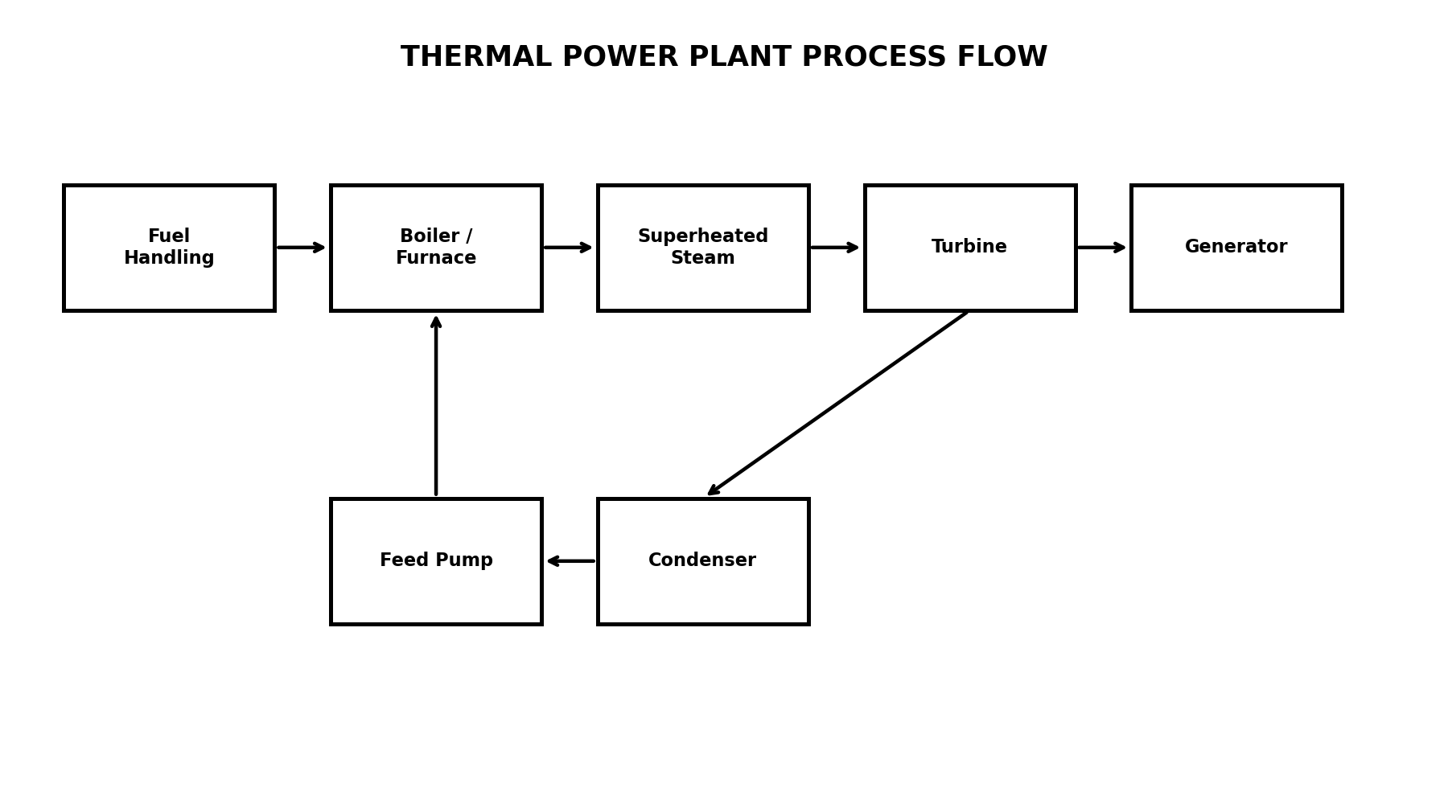
Figure 1: Simplified thermal power plant process flow

Fuel is delivered to the boiler where combustion supplies heat. Water is converted into high-pressure steam, which expands through the turbine. The turbine shaft drives the generator. Exhaust steam enters the condenser and is returned through the feed-water system.
In SCADA, each major stage has measurement points and equipment status signals. These signals form the basis for process graphics, alarms, trends and control functions.

3.

MAJOR PLANT COMPONENTS

The major components of a SCADA-based thermal power plant are:
- Boiler: Converts water into high-pressure steam using heat generated by fuel combustion.
- Steam Turbine: Converts the thermal energy of steam into mechanical energy.
- Generator (Alternator): Converts mechanical energy into electrical energy.
- Condenser: Converts exhaust steam from the turbine back into water.
- Feedwater Pump: Supplies water to the boiler at the required pressure.
- Cooling Tower: Cools the circulating water used in the condenser.
- Fuel Handling System: Transports and supplies fuel, such as coal, to the boiler.
- Ash Handling System: Collects and removes ash produced during coal combustion.
- Transformer: Increases the generated voltage for efficient power transmission.
- Sensors and Transmitters: Measure parameters such as temperature, pressure, flow, and water level.
- PLC/RTU: Collects sensor data and performs local monitoring and control functions.
- SCADA System and HMI: Displays real-time data, generates alarms, records operating parameters, and allows operators to perform supervisory control.
Component | Function | Important Parameters
Fuel handling | Stores and supplies fuel | Fuel flow, conveyor status, temperature
Boiler | Produces steam | Pressure, temperature, drum level
Superheater | Raises steam temperature | Outlet temperature, pressure
Turbine | Converts steam to shaft power | Speed, vibration, pressure
Generator | Produces electricity | Voltage, current, MW, frequency
Condenser | Condenses exhaust steam | Vacuum, temperature, level
Feed-water pump | Returns water to boiler | Flow, pressure, motor status
Cooling system | Removes waste heat | Flow, temperature, status
Switchgear | Connects generator to grid | Breaker, current, voltage

4.

BOILER AND STEAM GENERATION

The boiler is the central thermal component. Fuel combustion supplies heat to water. Steam is generated and, where applicable, superheated before entering the turbine.
- Boiler drum level must remain within an acceptable range.
- Steam pressure is continuously monitored.
- Steam temperature is important for turbine and material protection.
- Combustion air and fuel flow must be coordinated.
- Alarms and interlocks protect against dangerous conditions.
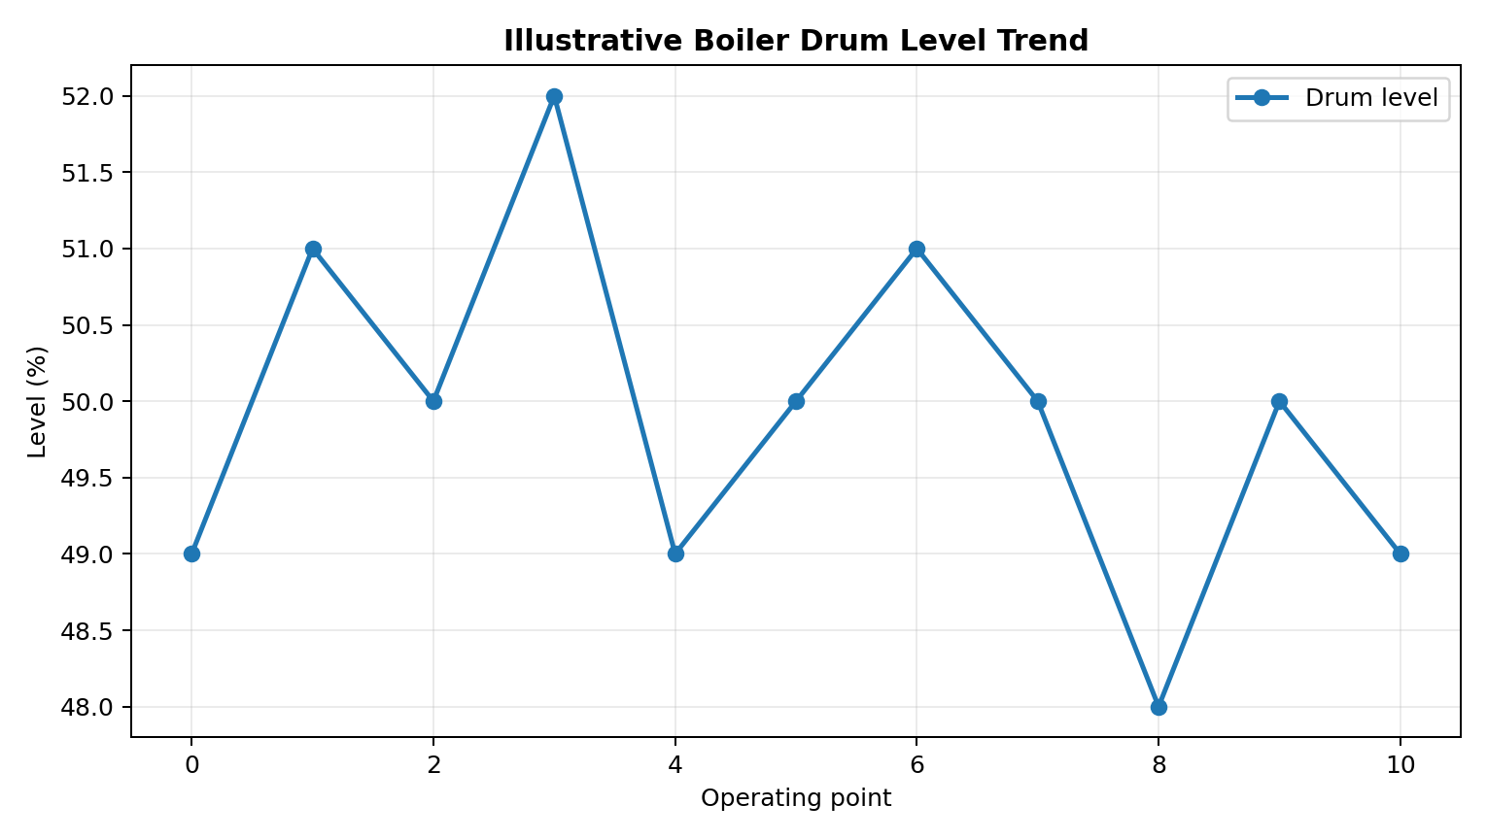
Figure 2: Illustrative boiler drum level trend

5.

STEAM TURBINE

The steam turbine converts the energy of expanding steam into rotational mechanical energy. The turbine is coupled to the generator through a shaft. Monitoring speed, vibration, bearing temperature, lubrication pressure and steam conditions is essential.
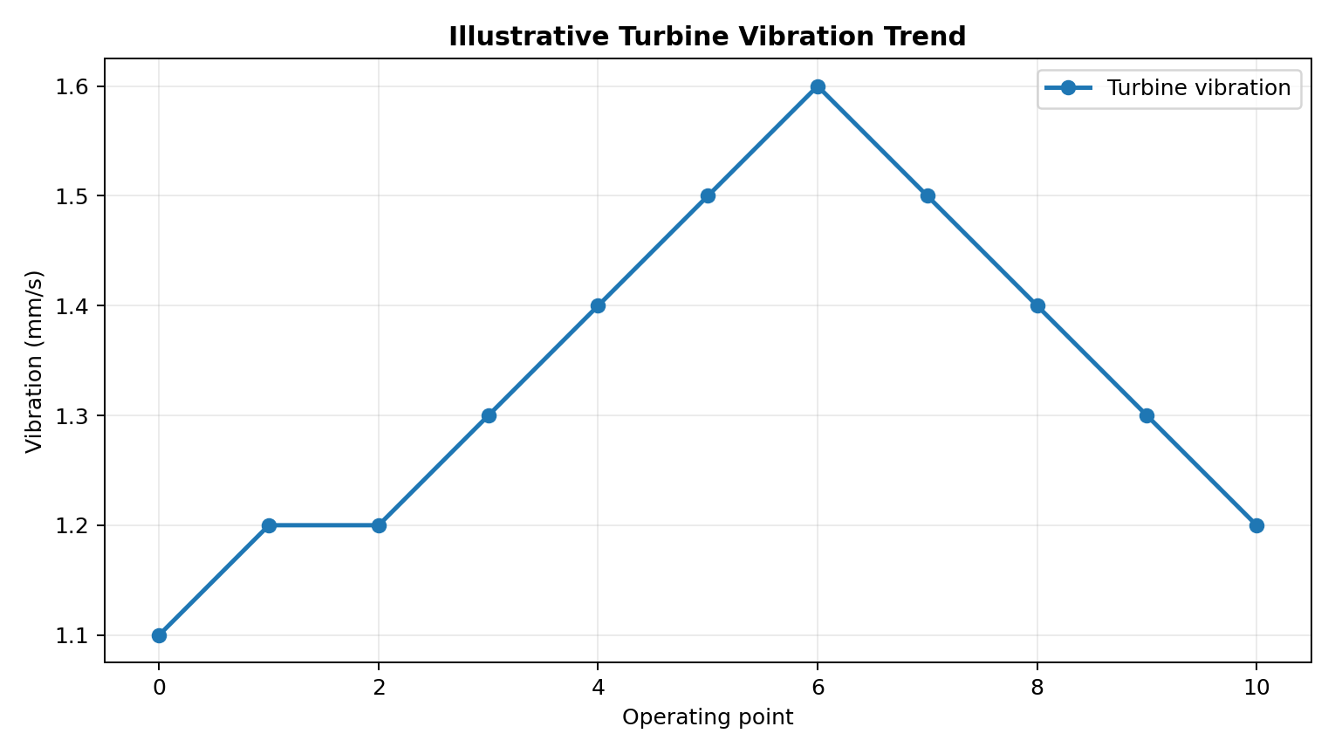
Figure 3: Illustrative turbine vibration trend
A rising vibration trend can indicate mechanical imbalance, misalignment, bearing problems or other developing conditions. SCADA can provide early warning while dedicated protection systems perform critical trips.

6.

GENERATOR AND ELECTRICAL SYSTEM
The generator converts turbine shaft power into electrical power. Electrical monitoring includes voltage, current, active power, reactive power, frequency, power factor and breaker status.
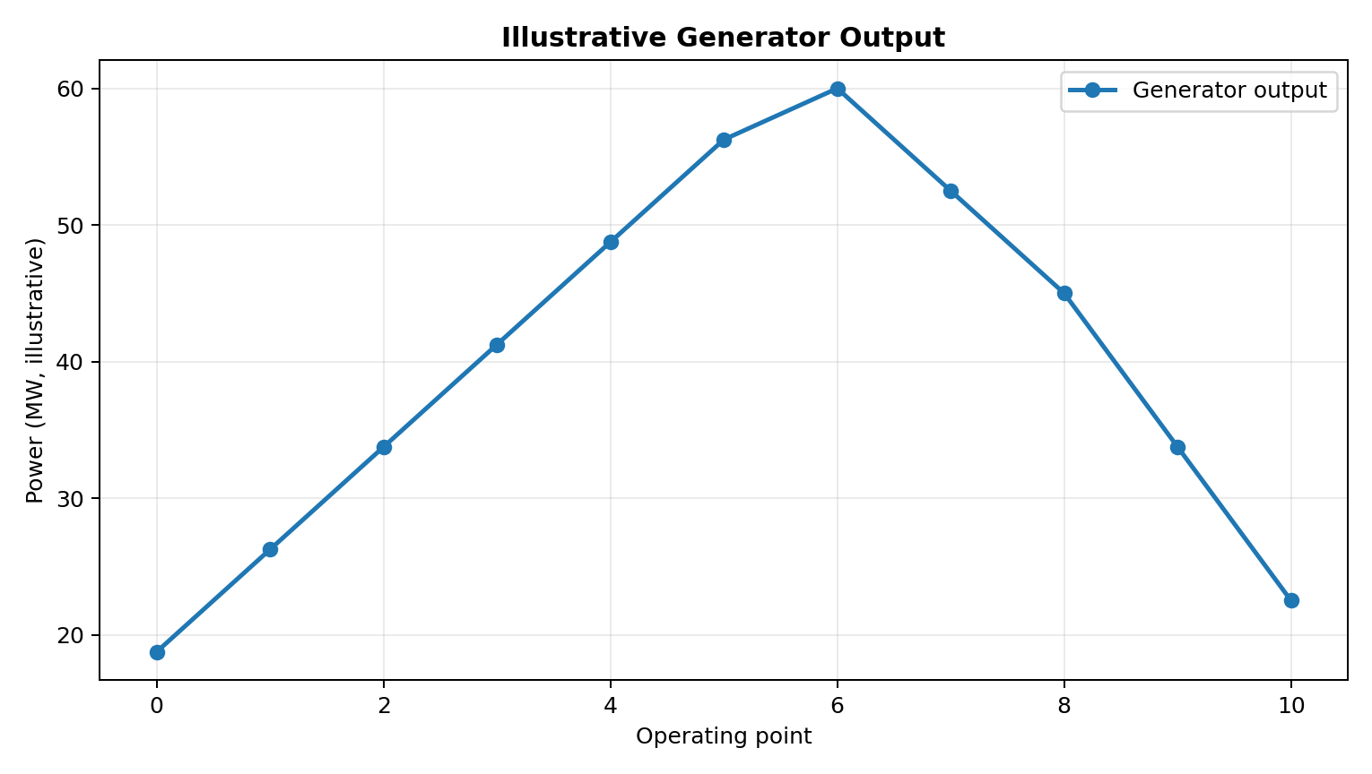
Figure 4: Illustrative generator output trend
Quantity | Purpose
Voltage | Monitor terminal voltage
Current | Monitor loading
Active power | Measure electrical output
Reactive power | Observe reactive loading
Frequency | Check system frequency
Power factor | Assess operating condition

7.

CONDENSER AND FEED-WATER SYSTEM

The condenser converts turbine exhaust steam back into water by transferring heat to a cooling medium. Good condenser performance supports turbine efficiency. Condensate then passes through pumps and feed-water equipment before returning to the boiler.
Important measurements include condenser vacuum, hotwell level, cooling-water temperatures, condensate flow and feed-pump discharge pressure.
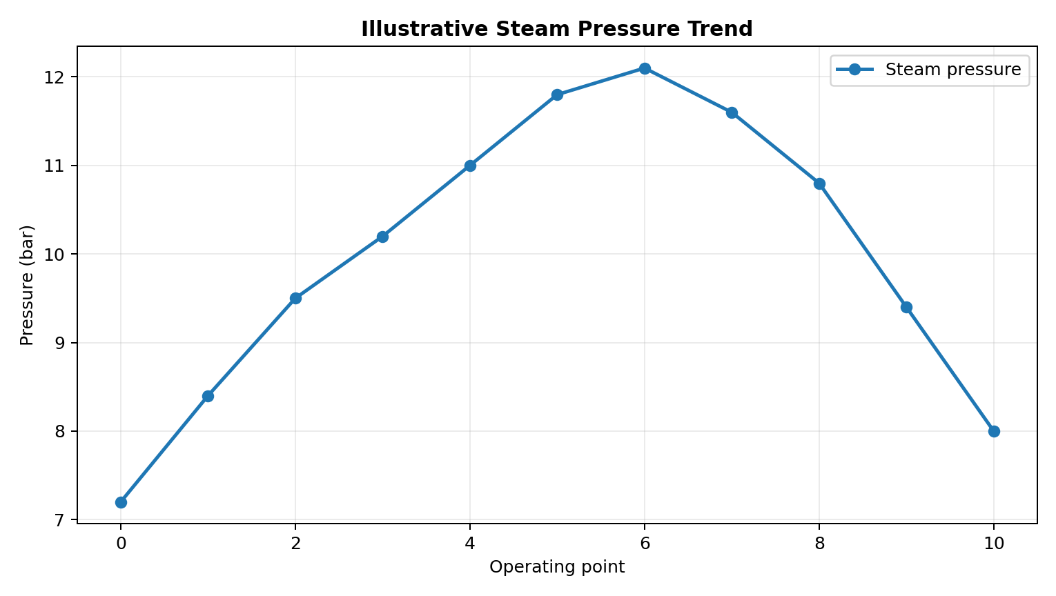
Figure 5: Illustrative pressure trend

8.

SCADA FUNDAMENTALS

SCADA means Supervisory Control and Data Acquisition. It is an industrial system for collecting data from field devices and presenting that data to operators. SCADA can also issue supervisory commands, subject to permissions and underlying control logic.
SCADA works by collecting data from field sensors through PLCs or RTUs. The data is transmitted through a communication network to a central computer, where it is displayed on the HMI. Operators monitor the process and send supervisory commands when required. Local controllers execute control actions, while the SCADA system records data and generates alarms for abnormal conditions.
SCADA is used to monitor boiler pressure and temperature, turbine speed, generator output, water flow, and pump operation. It supports alarm generation, fault detection, data logging, and performance analysis.
SCADA is an important industrial automation technology that enables centralized monitoring, data acquisition, and supervisory control. In thermal power plants, it helps improve operational efficiency, reliability, and safety by providing real-time information about plant equipment and processes.
Function | Description
Data acquisition | Collect analog and digital field values
Supervision | Provide an overall view of plant status
Visualization | Display process graphics and faceplates
Alarm management | Identify abnormal conditions
Historian | Store selected values
Reporting | Create operational reports
Supervisory control | Allow authorized commands

9.

SCADA ARCHITECTURE

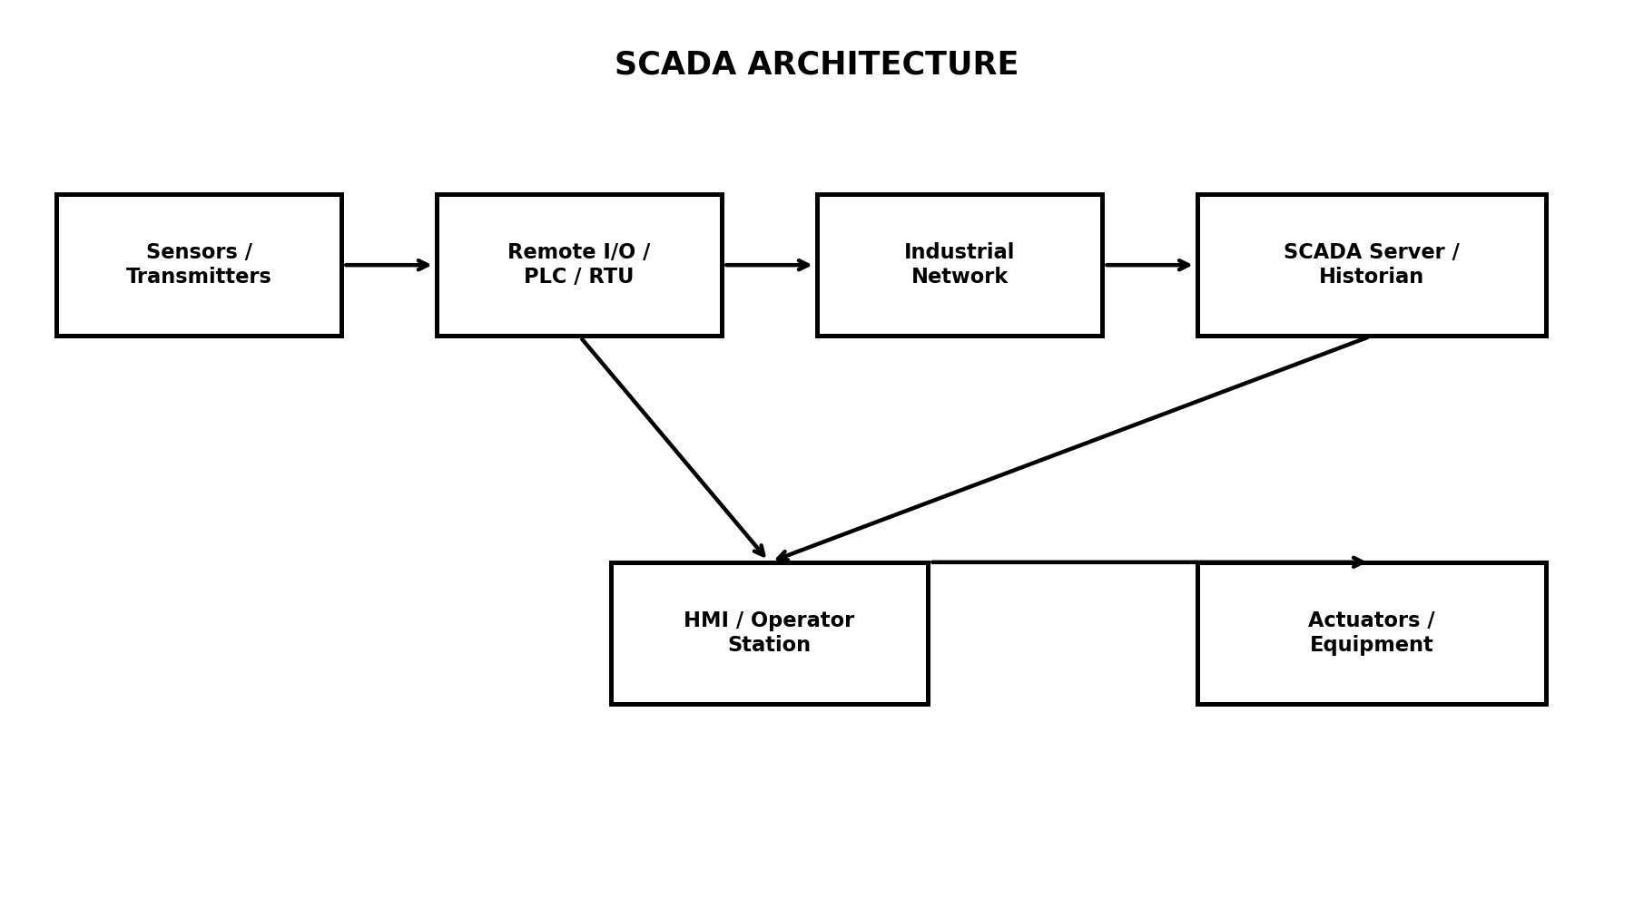
Figure 6: Conceptual SCADA architecture
Field instruments measure process variables and provide signals to PLCs/RTUs or remote I/O. Controllers execute control logic and communicate with SCADA servers. SCADA servers manage tags, alarms, historical data and communication services. Operator HMIs provide the graphical interface.
For high-availability plants, redundant servers, controllers, networks and power supplies may be implemented.

10.

SENSORS AND TRANSMITTERS

Sensors and transmitters are important components. They are used to measure physical parameters such as temperature, pressure, flow, and liquid level. Sensors detect changes in physical quantities, while transmitters convert the measured values into standard electrical signals and send them to PLCs, RTUs, or the SCADA system for monitoring and control.
The sensor detects a physical parameter and produces a corresponding signal. The transmitter converts this signal into a standard output, commonly 4–20 mA or a digital communication signal. The signal is transmitted to a PLC or RTU, which processes the data and makes it available to the SCADA system. Operators can then monitor the measured values and respond to abnormal conditions.
Sensors and transmitters are used to monitor boiler temperature, steam pressure, turbine speed, feedwater flow, condenser pressure, and tank water levels. They help operators maintain operating conditions, identify faults, and improve plant efficiency and safety.
Sensors and transmitters play a vital role in SCADA-based thermal power plants by providing accurate and continuous process measurements. They enable real-time monitoring, effective supervisory control, and reliable operation of plant equipment.
Variable | Instrument | Application | Signal
Pressure | Pressure transmitter | Steam header | 4–20 mA / digital
Temperature | RTD / thermocouple | Steam/bearings | Analog/digital
Flow | Flow transmitter | Feed water | 4–20 mA / digital
Level | Level transmitter | Drum/hotwell | 4–20 mA / digital
Speed | Speed pickup | Turbine shaft | Pulse/frequency
Vibration | Vibration transmitter | Turbine bearing | Analog/digital
Electrical | Power transducer | Generator | Analog/digital

11.

PLC AND RTU

Programmable Logic Controller (PLC)
A PLC is an industrial digital controller used to automate machines and industrial processes. It receives input signals from sensors, processes them according to programmed logic, and sends output signals to control devices such as motors, pumps, and valves.
Remote Terminal Unit (RTU)
An RTU is an electronic device used to collect data from remote field instruments and transmit it to a central SCADA system. It can also receive supervisory commands and control compatible field devices.
A PLC is an industrial controller designed for reliable real-time control. An RTU is commonly used for data acquisition and control at remote locations. In a thermal plant, controllers can perform sequencing, interlocking, analog control and equipment logic.
- Input processing and signal scaling.
- Sequence control for pumps and fans.
- Interlocking and permessives.
- PID or other closed-loop control.
- Equipment status and fault handling.
- Communication with SCADA.

PLCs and RTUs are essential components of SCADA systems. PLCs mainly perform local control functions, while RTUs commonly collect and transmit data from remote locations. Both help improve the efficiency, reliability, and monitoring of thermal power plant operations.
Fast and safety-critical functions are implemented in dedicated control/protection systems; SCADA provides supervisory visibility.

12.

INDUSTRIAL COMMUNICATION

Industrial devices measure process parameters and send data to PLCs or RTUs through communication networks other plant systems. Industrial Ethernet is widely used for higher-level communication, while field-level interfaces may use serial or specialized protocols.
Types of Industrial Communication
- Serial Communication: Transfers data sequentially between devices using standards such as RS-232 and RS-485.
- Ethernet Communication: Provides high-speed data transmission between PLCs, SCADA servers, and industrial computers.
- Wireless Communication: Transfers data without physical cables, useful for remote monitoring.
- Fieldbus Communication: Connects industrial instruments and controllers using networks such as PROFIBUS and Modbus.
- Industrial Ethernet: Uses protocols such as PROFINET and Ethernet/IP for communication in industrial automation systems.
Technology | Typical Role | Key Consideration
Modbus TCP/RTU | Device/controller communication | Configuration and diagnostics
OPC UA | Structured data exchange | Security/interoperability
PROFINET | Industrial Ethernet control | Deterministic communication
EtherNet/IP | Industrial automation | Device integration
Industrial Ethernet | Plant backbone | Redundancy/segmentation

13.

HMI AND OPERATOR DISPLAYS
HMI:-
HMI stands for Human-Machine Interface. It is a graphical interface that allows operators to interact with industrial machines and control systems. In a SCADA-based thermal power plant, HMI and operator displays provide real-time information about plant operations, equipment status, alarms, and process parameters. They help operators monitor and supervise the plant from a centralized control room.
OPERATOR DISPLAYS:-
Operator displays are graphical screens used to present plant information in an understandable format. Common displays include process overview screens, boiler monitoring screens, turbine monitoring screens, alarm screens, trend graphs, and equipment status screens.
These displays help operators identify abnormal conditions, observe plant performance, and take appropriate action.
Functions of HMI:-
- Real-Time Monitoring: Displays temperature, pressure, flow rate, water level, and generator output.
- Equipment Control: Allows authorized operators to issue commands to start or stop equipment through the control system.
- Alarm Management: Displays warnings and alarms when abnormal operating conditions occur.
- Trend Display: Shows historical and real-time parameter variations using graphs.
- Process Visualization: Represents boilers, turbines, pumps, valves, and pipelines using graphical symbols.
- Data Logging: Supports recording and reviewing operational information for analysis.

14.

ALARM AND EVENT MANAGEMENT

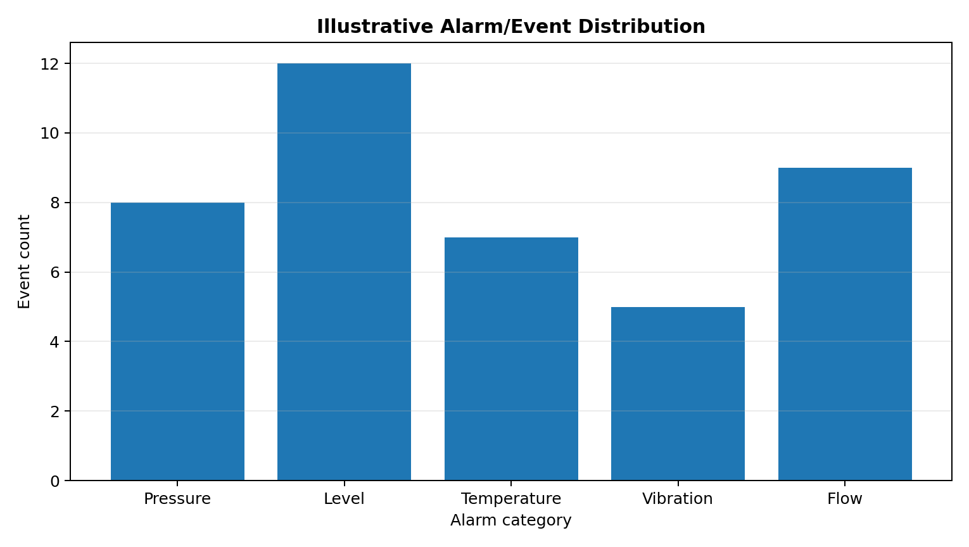
Figure 7: Illustrative alarm/event distribution
Alarms indicate conditions that require operator awareness or action. Priorities should reflect consequence and urgency. Each alarm should have a defined cause, operator response and return-to-normal condition.
Alarm | Possible Meaning | Typical Response
High drum pressure | Pressure approaching limit | Verify controls and operating procedure
Low drum level | Insufficient water inventory | Check feed system
High bearing temperature | Cooling/lubrication issue | Check equipment
High vibration | Mechanical abnormality | Investigate/protect equipment
Pump trip | Loss of auxiliary | Start standby if permitted

15.

DATA HISTORIAN AND TRENDS

A historian stores time-stamped process information so operators and engineers can review past operation. Historical data is useful for efficiency studies, troubleshooting, maintenance and reporting.
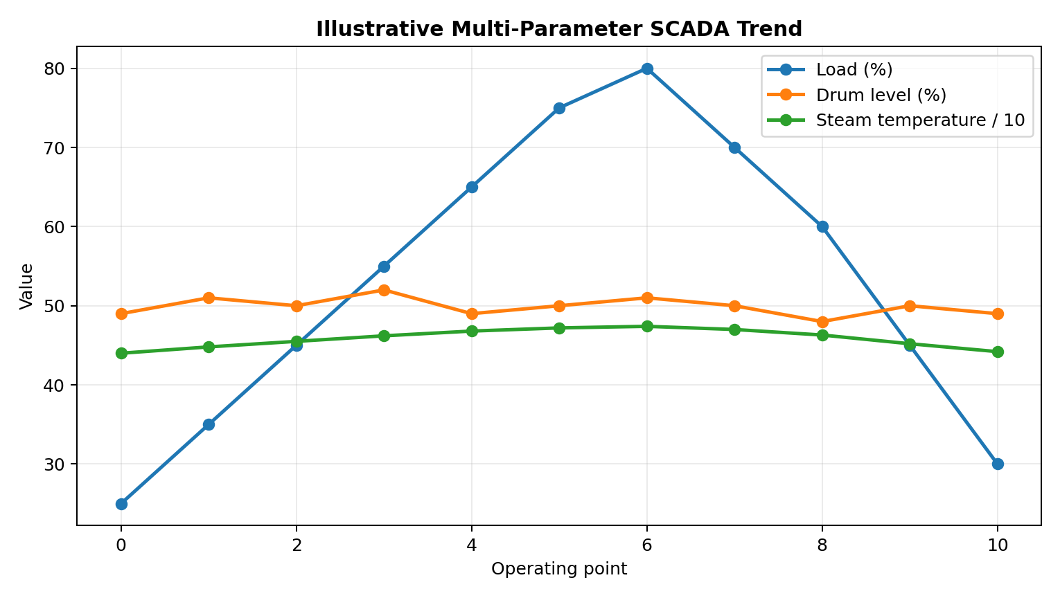
Figure 8: Illustrative multi-parameter SCADA trend
Trend analysis allows engineers to compare variables, identify drift and investigate sequences of events. Data-quality indicators are important so communication failures are not mistaken for real process changes.

16.

CLOSED-LOOP CONTROL

Main Components:-
- Setpoint: The desired value of the process parameter.
- Sensor/Transmitter: Measures the actual process value.
- Controller: Compares the measured value with the setpoint and calculates the control action.
- Actuator/Control Valve: Adjusts the process according to the controller output.
- Process/Plant: The system being controlled.
- Feedback: Returns the measured output to the controller for comparison.
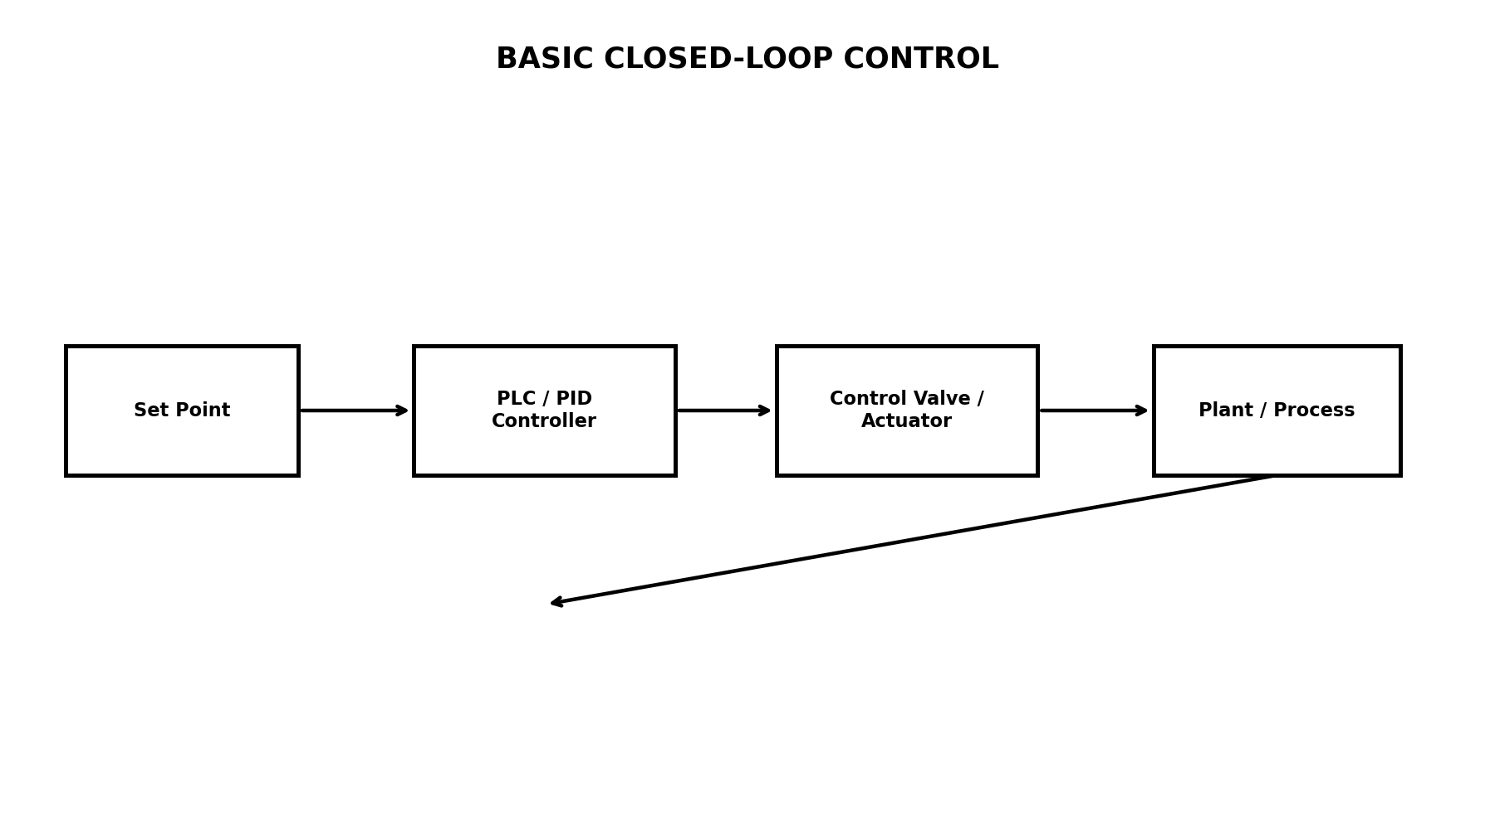
Figure 9: Basic closed-loop control
A closed-loop system measures a process variable and compares it with a desired set point. The controller calculates a corrective output that changes the final control element. The process is measured again, forming feedback.
SCADA displays set point, process value, output and alarm status while the PLC/control system performs the rapid control action.
17.

BOILER CONTROL LOOPS

Common boiler control loops include drum-level control, steam pressure control, steam temperature control and combustion air/fuel coordination. A three-element drum-level strategy can use drum level, steam flow and feed-water flow to improve response during load changes.
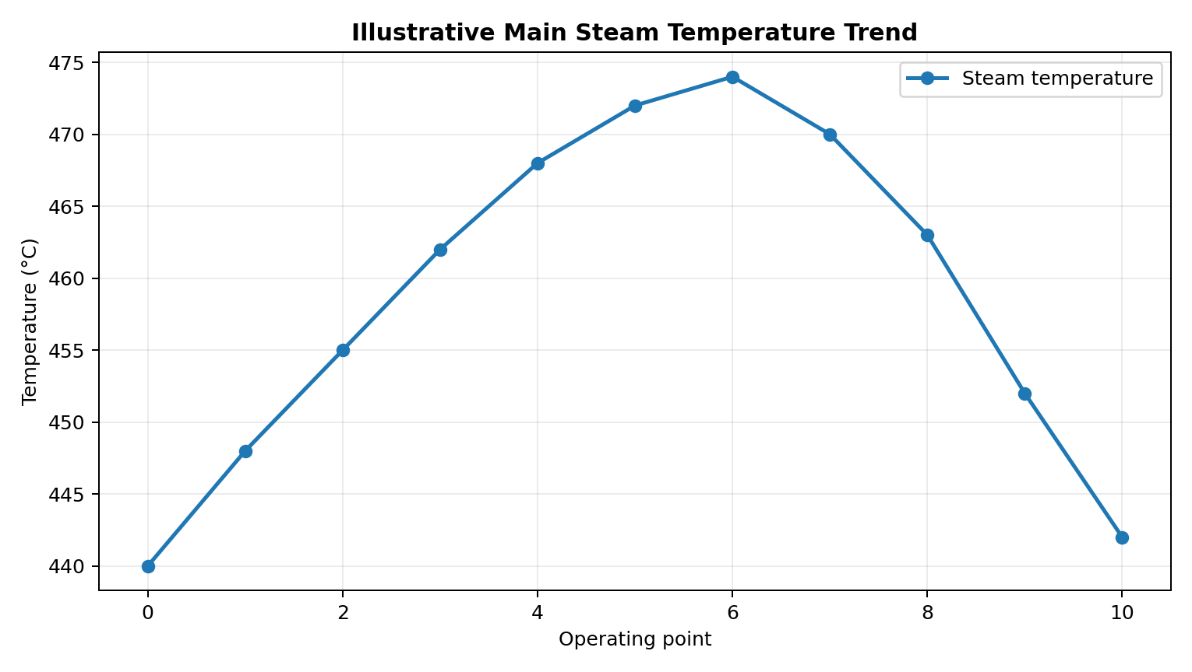
Figure 10: Illustrative steam temperature trend
Loop | Controlled Variable | Manipulated Variable
Drum level | Water level | Feed-water flow
Steam temperature | Steam temperature | Attemperation / firing control
Steam pressure | Main steam pressure | Fuel/combustion input
Air-fuel | Combustion balance | Air and fuel flow

18.

TURBINE AND AUXILIARY CONTROL

Turbine and auxiliary control are important functions. Turbine control manages the operation, speed, load, and safety of the steam turbine, while auxiliary control supervises supporting equipment such as pumps, fans, valves, and lubrication systems. SCADA enables operators to monitor these systems and supervise their operation from a centralized control room.
Turbine and auxiliary control are essential for reliable thermal power generation. Integration with SCADA provides centralized monitoring, alarm management, and supervisory control, helping maintain stable turbine operation and efficient performance of supporting equipment.
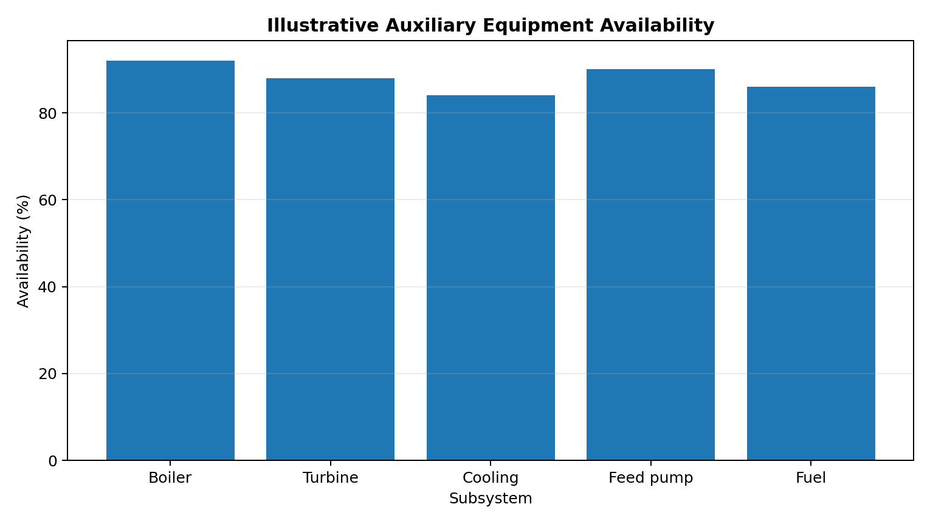
Figure 11: Illustrative auxiliary equipment availability
Standby equipment can be configured with permessives and automatic changeover where the plant design permits.

19.

ELECTRICAL MONITORING

Electrical monitoring is the process of measuring and supervising electrical parameters to ensure the safe, reliable, and efficient operation of electrical equipment. In a SCADA-based thermal power plant, electrical monitoring is used to observe generator output, voltage, current, frequency, power, and energy consumption. The collected data is displayed in the control room to help operators monitor plant performance and detect abnormal conditions.
Electrical monitoring is an essential function of a SCADA-based thermal power plant. It provides continuous information about electrical parameters and equipment status, helping operators improve system reliability, operational efficiency, and safety.
Parameters of Electrical Monitoring
- Voltage: Measures the electrical potential difference in the system.
- Current: Measures the flow of electric charge through a conductor.
- Frequency: Measures the frequency of the generated AC supply, typically 50 Hz in India.
- Active Power (kW/MW): Indicates the electrical power being used or delivered.
- Reactive Power (kVAR/MVAR): Indicates reactive power associated with magnetic and electric fields.
- Power Factor: Indicates the relationship between active power and apparent power.
- Energy (kWh/MWh): Measures the electrical energy generated or consumed.
Screen Element | Purpose
Generator overview | Observe electrical output
Breaker status | Verify connection state
Protection status | Show trip/healthy indications
Trend display | Study electrical changes
Energy counter | Support reporting

20.

SAFETY, INTERLOCKS AND TRIPS
Safety, interlocks, and trips are essential features. They protect personnel, equipment, and plant processes from hazardous operating conditions. These systems monitor plant parameters, prevent unsafe operations, and initiate protective actions when abnormal conditions occur.
Safety Systems:-
Safety systems are designed to minimize risks and ensure the safe operation of plant equipment. Sensors, alarms, emergency shutdown systems, and protective devices help identify dangerous conditions and prevent accidents. In thermal power plants, safety systems monitor boiler pressure, temperature, water level, turbine vibration, and electrical faults.
Interlocks:-
An interlock is a control mechanism that permits or prevents an operation based on predefined conditions. It ensures that equipment operates only when the required safety and operating conditions are satisfied.
Examples of interlocks:-
- Preventing boiler firing when the required permissive conditions are not met.
- Preventing a pump from starting when essential operating conditions are unsatisfied.
- Preventing equipment startup when lubrication or cooling requirements are not fulfilled.
- Ensuring appropriate startup sequences for fans, pumps, and other auxiliary equipment.
Trips:-
A trip is an automatic protective action that stops equipment or shuts down a process when a dangerous condition is detected. Trips help prevent equipment damage and protect personnel.
Examples of trips:-
- Boiler trip due to dangerously low drum water level.
- Turbine trip due to overspeed or serious vibration.
- Generator trip due to specified electrical faults.
- Motor trip due to overload or short circuit.

21.

CYBERSECURITY

Cybersecurity is the protection of computer systems, communication networks, and industrial control systems from unauthorized access, cyberattacks, and data theft. In a SCADA-based thermal power plant, cybersecurity is essential for protecting PLCs, RTUs, SCADA servers, HMI systems, and communication networks. It helps ensure the safe, reliable, and continuous operation of power generation.
Common Cybersecurity Threats:-
- Unauthorized Access: Accessing control systems without permission.
- Malware Attacks: Malicious software that can disrupt system operation.
- Network Attacks: Attacks that interrupt communication between controllers and SCADA systems.
- Data Manipulation: Unauthorized modification of process data or control commands.
- Phishing: Fraudulent messages designed to steal credentials or gain access to systems.
Cybersecurity Measures:-
- Access Control: Use strong passwords, role-based permissions, and multifactor authentication where supported.
- Network Segmentation: Separate control networks from corporate IT networks and restrict unnecessary connections.
- Firewalls: Filter network traffic to prevent unauthorized communication.
- System Updates: Apply tested security patches according to plant maintenance procedures.
- Monitoring and Logging: Record system activity and detect suspicious behavior.
- Backup and Recovery: Maintain protected backups and test recovery procedures.
- Employee Training: Educate staff about phishing, removable media risks, and secure operating practices.

22.

PERFORMANCE MONITORING
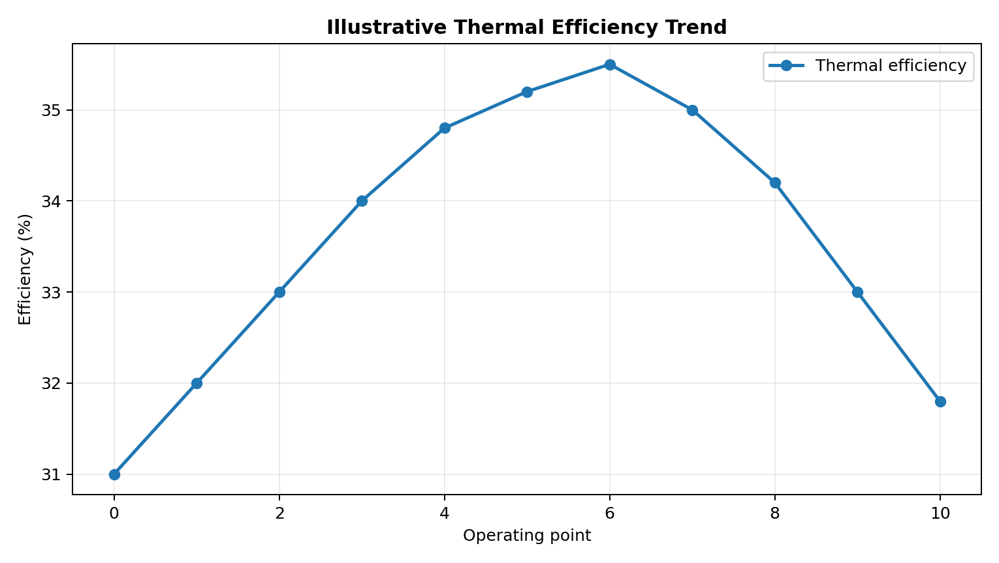
Figure 12: Illustrative thermal efficiency trend
Performance monitoring compares operating conditions with expected performance. Important indicators include generator output, heat input, steam conditions, auxiliary power, condenser performance and overall efficiency.
A SCADA historian can provide data needed to calculate trends, compare operating periods and identify deterioration. Engineering calculations should use validated plant measurements and defined performance procedures.

23.

ILLUSTRATIVE GRAPH ANALYSIS
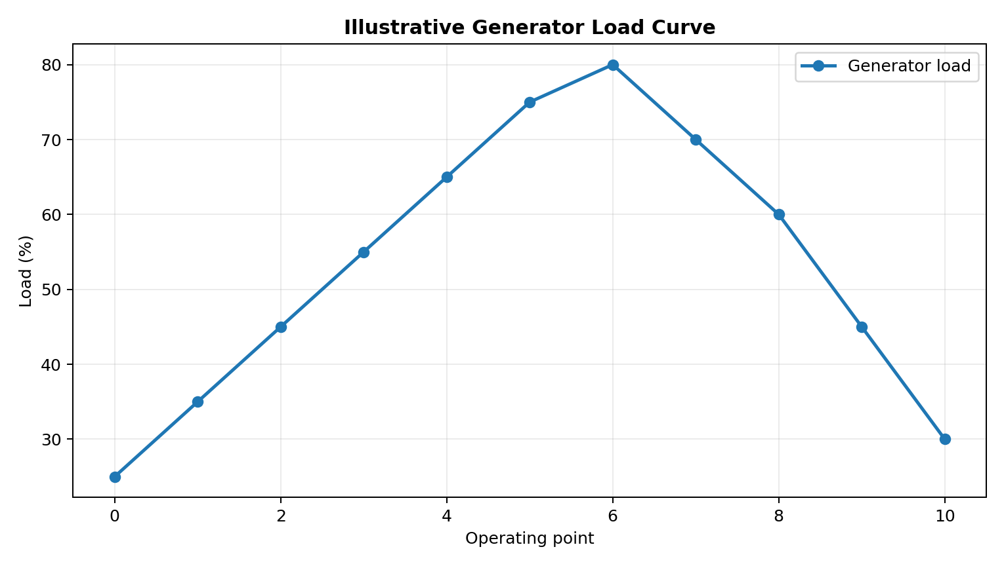
Figure 13: Illustrative generator load curve
The load curve demonstrates how an operator can visualize changes in generation demand. The values are illustrative. In an actual plant, the trend would be generated from validated SCADA tags.
Figure 14: Illustrative pressure trend
Comparing load and pressure trends can help engineers investigate the relationship between generation demand and process conditions.
24.

MAINTENANCE AND TROUBLESHOOTING

Maintenance and troubleshooting are essential activities to ensure reliable, safe, and efficient operation. Maintenance involves regular inspection and servicing of equipment, while troubleshooting is the process of identifying and correcting faults in the system. These activities help reduce equipment failures, minimize downtime, and improve plant performance.
Types of Maintenance:-
- Preventive Maintenance: Regular inspection, cleaning, testing, and servicing of equipment to prevent failures.
- Corrective Maintenance: Repairing or replacing faulty components after a problem is identified.
- Predictive Maintenance: Using equipment condition and operating data to predict potential failures before they occur.
Troubleshooting in SCADA Systems:-
Troubleshooting involves identifying faults in sensors, transmitters, PLCs, RTUs, communication networks, HMI displays, and other plant equipment.
Common problems and solutions:-
- Sensor Failure: Check sensor connections, calibration, and signal readings.
- Communication Failure: Inspect network connections, communication settings, and device status.
- PLC/RTU Fault: Check controller diagnostics, power supply, input/output signals, and fault indicators.
- HMI Display Issues: Verify server connectivity, data tags, and configuration.
- Abnormal Readings: Compare instrument readings with independent measurements and inspect the instrument for faults.

25.

ADVANTAGES AND LIMITATIONS

Advantages:-
- Real-Time Monitoring: SCADA continuously monitors parameters such as temperature, pressure, water level, and power output.
- Improved Efficiency: Helps optimize plant operations and reduce energy losses.
- Reduced Human Error: Automation reduces the need for continuous manual operation.
- Fault Detection: Generates alarms when abnormal operating conditions occur.
- Increased Reliability: Supports continuous monitoring and timely maintenance.
- Data Logging: Stores historical data for performance analysis and reporting.
- Remote Supervision: Allows operators to monitor and supervise plant equipment from a centralized control room.
- Improved Safety: Supports safe operation through alarms, interlocks, and integration with protective systems.
Limitations:-
- High Initial Cost: Installation of SCADA hardware, software, sensors, and communication networks can be expensive.
- Maintenance Requirements: Regular maintenance and system updates are necessary.
- Cybersecurity Risks: Network-connected systems may be vulnerable to cyberattacks.
- Dependence on Communication: Network or communication failures can interrupt data transmission and supervisory functions.
- Skilled Personnel Required: Trained operators and technicians are needed to operate and maintain the system.
- System Complexity: Configuration, integration, and troubleshooting can be challenging.
- Power Supply Dependence: Failures in power supplies or supporting infrastructure can affect system availability.

26.

FUTURE SCOPE

The future scope of SCADA-based thermal power plants is promising due to advancements in automation, digital technologies, and industrial control systems. SCADA can be integrated with modern technologies to improve power generation efficiency, reliability, safety, and environmental performance.
SCADA-based thermal power plants can become more intelligent, efficient, and reliable through the integration of AI, IoT, predictive maintenance, and advanced cybersecurity. These developments will help reduce operating costs, minimize downtime, improve environmental performance, and support the future modernization of power generation systems.
Future Developments:-
- Artificial Intelligence (AI): AI can analyze plant data to optimize operating conditions and improve performance.
- Predictive Maintenance: Advanced monitoring can identify early signs of equipment failure and reduce unexpected shutdowns.
- Internet of Things (IoT): Smart sensors can provide continuous data from plant equipment for improved monitoring and control.
- Cloud Computing and Data Analytics: Secure data platforms can support historical analysis, performance evaluation, and operational planning.
- Advanced Cybersecurity: Improved security technologies can protect SCADA systems against unauthorized access and cyber threats.
- Energy Efficiency: Advanced control strategies can optimize fuel consumption and improve overall plant efficiency.
- Environmental Monitoring: SCADA can support continuous monitoring of emissions, water usage, and other environmental parameters.
- Digital Twin Technology: Virtual models of plant equipment can help simulate operating conditions and support maintenance planning.

27.

CONCLUSION
A SCADA-based thermal power plant is an advanced industrial automation system that plays an important role in the efficient, reliable, and safe generation of electrical energy. SCADA stands for Supervisory Control and Data Acquisition. It combines modern monitoring, communication, and control technologies to supervise different operations of a thermal power plant from a centralized control room. The integration of SCADA with industrial instruments and controllers helps improve plant performance and reduces the need for continuous manual intervention.
In a thermal power plant, electricity is generated by converting the chemical energy of fuel into heat energy, mechanical energy, and finally electrical energy. SCADA supports the monitoring and supervision of major plant components, including the boiler, steam turbine, generator, condenser, feedwater pumps, cooling system, and auxiliary equipment. Sensors and transmitters measure important parameters such as temperature, pressure, flow rate, water level, turbine speed, voltage, current, and power output. These measurements are transmitted through PLCs, RTUs, and communication networks to the SCADA system, where operators can observe real-time operating conditions.
SCADA also contributes to improved operational efficiency by helping operators monitor fuel consumption, steam conditions, water flow, and electrical output. When integrated with suitable control systems, it supports the regulation of process parameters and the coordinated operation of plant equipment. HMI displays provide a user-friendly interface through which operators can view process diagrams, equipment status, alarms, and trends. Interlocks and dedicated protection systems provide additional support for safe operation by preventing unsafe actions and responding to hazardous conditions.
The future of SCADA-based thermal power plants is promising because of advancements in Artificial Intelligence (AI), the Internet of Things (IoT), advanced data analytics, and predictive maintenance. These technologies can help identify potential equipment failures at an early stage, optimize plant operating conditions, reduce maintenance costs, and improve energy efficiency. Advanced monitoring systems can also support environmental monitoring by tracking emissions, water consumption, and other important operating parameters.
In conclusion, a SCADA-based thermal power plant represents an important application of industrial automation in the power generation sector. By integrating real-time monitoring, supervisory control, data acquisition, alarm management, and communication technologies, SCADA helps improve the efficiency, reliability, and safety of plant operations. Although certain technical and financial challenges must be addressed, the effective implementation of SCADA can provide significant long-term benefits. With continuous technological development and proper maintenance, SCADA-based thermal power plants can achieve better operational performance and contribute to a more reliable electricity supply.
28.

REFERENCES AND APPENDIX
References:-
- Standard textbooks on Steam Power Plants and Thermal Engineering.
- Standard textbooks on Electrical Power Generation and Power Plant Engineering.
- Standard textbooks on Industrial Instrumentation and Measurement.
- Standard PLC and SCADA/Industrial Automation textbooks.
- IEC/ISA guidance relevant to industrial automation and control systems.
- Manufacturer manuals for PLC, SCADA, HMI and industrial communication systems.

Appendix A:- Abbreviations
Abbreviation | Full Form
SCADA | Supervisory Control and Data Acquisition
PLC | Programmable Logic Controller
RTU | Remote Terminal Unit
HMI | Human-Machine Interface
AI | Artificial Intelligence
IoT | Internet of Things
RTD | Resistance Temperature Detector
UPS | Uninterruptible Power Supply
VFD | Variable Frequency Drive
DCS | Distributed Control System

29.

Appendix B:- Major Parameters Monitored
Parameter | Measuring Device
Temperature | Thermocouple or RTD
Pressure | Pressure transmitter
Flow rate | Flow transmitter
Water level | Level transmitter
Turbine speed | Speed sensor
Voltage and current | Electrical meters or transducers
Power output | Power meter

Appendix C:- Major SCADA Components
The major components of a SCADA-based thermal power plant include sensors, transmitters, PLCs, RTUs, communication networks, SCADA servers, HMI displays, alarm systems, and data historians. These components work together to collect process data, monitor equipment, display operating conditions, and support supervisory control.
Appendix D:- Example Applications
SCADA can be used for boiler monitoring, turbine supervision, generator monitoring, pump control, alarm management, electrical monitoring, fault detection, and maintenance planning in thermal power plants.

30.

THANK YOU
Thank you for taking your valuable time to go through my project file.
I sincerely appreciate your guidance, support, and encouragement.
Thank You!

